WEB701 Project: Milestone One

Carlos Amos

Contents

Executive Summary/ Abstract 3

Introduction. 3

Website Brief. 3

Website Goals. 3

Mission or Purpose. 3

Short and Long-Term goals. 4

Intended Audience. 4

User Experience. 4

Audience. 4

First type of Audience. 4

Second Type of Audience. 4

Scenarios. 4

Competitive Analysis. 5

Website 1 – Purehands 5

Website 2 – Variety 5

Website 3 – World Vision 5

Site Content 6

Site Map 6

Site Structure. 6

Navigation. 7

Content. 7

Fonts. 7

Colours. 7

Metaphors. 7

Define Navigation. 8

Visual Design 9

Wireframes 9

Home 9

Store 10

Listings 12

News 13

Login 14

Register 16

Donate 17

Crud Analysis. 18

User Stories. 18

Summary and Conclusion 19

# Executive Summary/ Abstract

This document is a report on the Supplies for School website project. It will contain the goals and intended audience for the website along with an analysis of other websites that are in the same category as this project. It will also contain a map of the structure of the website including the looks and functionality. The aim of this report is to list the requirements of the project to meet the clients requirements.

# Introduction.

## Website Brief.

The Charity Supplies for Students is to supply students with school supplies.

The Supplies for Students charity is a charity that will offer school supplies to students/families within the Nelson community that can be purchased with tokens. Supplies for Students will let providers register and list the products they are providing. They will also have the possibility of working with schools in the Nelson region to get the supplies to the students that need it.

The following features will be needed:

- Elements that engage the user.

- Providers can register and state what items they are supplying.

- Members of the community can view what supplies are available and sort by type.

# Website Goals.

## Mission or Purpose.

The purpose of the website is for members of the community to use the website to donate school supplies so the people that need the supplies can view what has been donated.

Charity members will be able to register and list the products they will be providing, and members of the community will be able to select and purchase available supplies using tokens of which a limited number of tokens will be supplied when the beneficiaries register.

## Short and Long-Term goals.

The short-term goal of the website is to show what supplies are available in the Nelson area that can

## Intended Audience.

The intended audience of this website are for students who are in need of school supplies whether it is books or pens, they will be able to view what supplies are available and purchase the supplies using tokens that have been given to the student/beneficiary.

# User Experience.

## Audience.

The audience of the website are the beneficiaries and the community/charity members that are providing the supplies

## First type of Audience.

The first type of audience for this website would be the charity members as they will be using the website to display what supplies they have to offer.

## Second Type of Audience.

The second type of audience for the website would be the beneficiaries as they are the members that will use the website to view what is on for offer and to purchase supplies.

## Scenarios.

**Scenario One**

Greg is a member within the local community and has just finished high school. Over time he has accumulated many textbooks, books and pens. As Greg is continuing to University the next year, he decides to donate his books and pens to other members within the community and decides to use the Supplies for School charity. He visits the website where he first creates an account and then creates a listing on the listing page. The listing he creates has a title of the supplies and a description of how many items there are. He then takes a photo of all the supplies on offer, then creates the listing, and then Greg now waits for someone to purchase the supplies.

**Scenario Two**

Karen is currently a student attends a high school in the Nelson Area. She is starting her final year of high school and requires textbooks for her Physics and Chemistry class, but she is unable to buy them. She finds the Supplies for School charity and looks to find the textbooks she needs. She first opens the website to see what the charity is about and decides to go through this charity. She first creates an account and states that she is a beneficiary for this charity. She then browses through the listings and happens to come across the two textbooks she needs. She then purchases the books using the tokens she received.

**Scenario Three**

John has come across the Supplies for Schools charity and decides to see what the website is about before donating. He reaches the bottom of the home page and decides he would like to donate to this charity. He first clicks the donate button in the top right on the navbar and it takes him to the donate page. He enters the amount he wants to donate and his email and clicks the donate button. He then receives an email thanking him for his donation.

## Competitive Analysis.

### Website 1 – Purehands

When loading into the education section of the Purehands website, the first content that appears is a large picture with a header saying “Education.” And there is a definition on what this section is about. Underneath the picture is the option to sponsor four different options. Underneath this section is another donate section where the user can select what amount to donate or a custom amount towards an education project.

**Useful Traits**

* Uses the colours blue and orange to make the page not look bland.
* And lots of content like a picture at the top of the page and pictures within the donate buttons. Makes the page look intriguing.
* Has not only a sticky navbar but it is also transparent.
* Mobile friendly

**Non-useful Traits**

### Website 2 – Variety

When loading into the website, the website is filled with content. Both pictures but also information about what the website is about and their purpose. On the home page there are many content boxes that each have their own header and own content. The font on the website along with the colour choices make the content easy to read. The donate and sponsor a child button are in boxes that have a coloured background making them stand out but they also remain at the top of the navbar in mobile mode.

**Useful Traits**

* Website is easy to read.
* Uses the colour red throughout the website
* Moblie friendly

**Non-useful Traits**

* Sign in/register links are at the top but aren’t sticky.

### Website 3 – World Vision

World Vision has a section on their website where people can donate money to go towards school supplies for students.

When loading up the page, the first content that appears is the donate button with the amount the user would like to donate. Under the donation section is a brief on what the user will be donating too. At the bottom of the page is another section with a donate button and a form where users can sign up to a newsletter.

**Useful Traits**

* The first content the user sees is the donation button.
* Information on what the charity is for and who will benefit from it.
* Also has a video on what the charity is about.
* Mobile friendly

**Non-useful Traits**

* Navigation bar doesn’t move when scrolling down (Will have to scroll up every time a user wants to visit another page).

From looking at these three sites, it has given me an understanding of what the requirements for the website will be. Below in the site content section is what I’ve decided on for the content and functionality of the website.

# Site Content

## Site Map

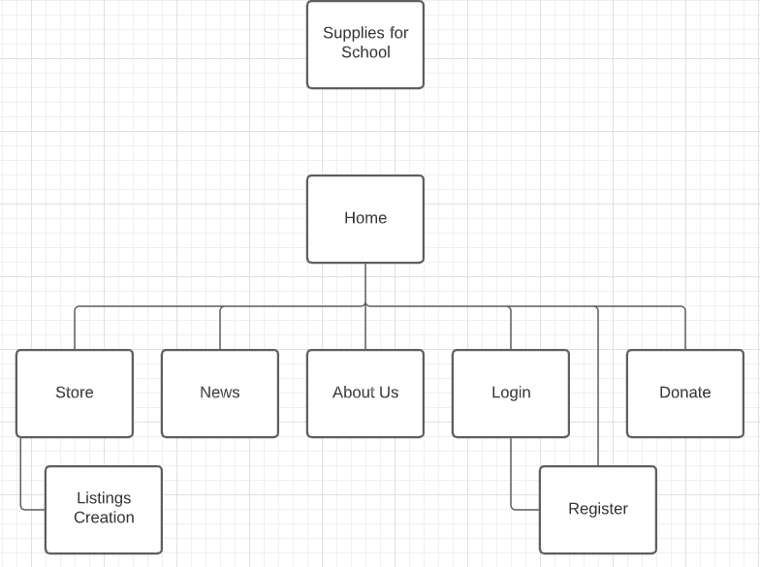

Note: About us page will be merged with home page.

## Site Structure.

The site will be structured with seven pages

* Home
* Store
* Listings
* News
* Login
* Register
* Donate

## Navigation.

The navigation links on the navigation bar will go to the specified pages. The home page, store, news, who are we/ about us and donate page. There will also be a search bar on the navigation bar that the user will use to search for content within the website.

## Content.

The content that will be used on the website are

* List of supplies
* Photos
* Information of what the charity is about

## Fonts.

The font for all the text within the website will be ‘Roboto.’

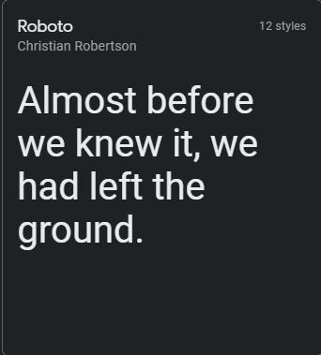

For all Titles and subtitles I will be using the Roboto thick font. 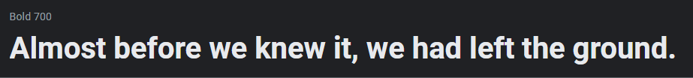

For all text within the website, I will be using the thin font.



## Colours.

For the colours of the website, they will be a split complementary of three colours, red, blue and green.

* #e0140d
* #0dc4e0
* #69e00d

## Metaphors.

* Nav buttons will be clear and easy to read. Current page button will be highlighted in a darker colour.
* Hovering over the nav buttons will be highlighted in a lighter colour.
* Any links within the website will have an active link font (Link)
* Examples for the fields on the listing page will be shown above the input fields
* Examples will also be given on the register page.
* Content boxes will be laid out apart at a reasonable distance so it’s easy to read.
* News content boxes will be laid out in organised columns so its easy to read.
* Layout of the pages will remain the same where the Navigation bar will be a sticky bar so it remains at the top when scrolling down, the content will remain in the centre of the page, headings will be thick, subheadings will be less thick, and the footer will remain at the bottom.

## Define Navigation.

**Global**

Global navigation is what is visible to the user to use.

**Local**

Local navigation is used for navigation in a section of the website.

# Visual Design

## Wireframes

### Home

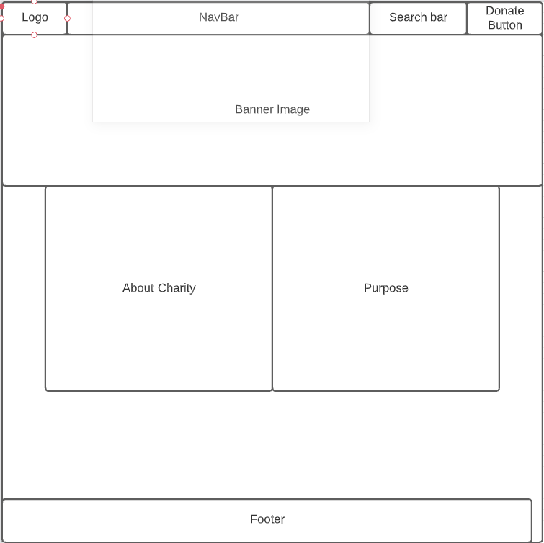

**Description**

This is the first page the user will see. When the get to the home page, they will first see a banner image at the top of the page which will contain pictures related to the charity and it will have a slideshow of images. Underneath the banner will be two content boxes of which the box on the left will have information about the charity and the content box on the right will have the charities purpose and why they exist.

**Title**

Home

**Headings**

H2 – Who are we?

H2 – Our Purpose

**Content**

* Top banner images
* About us statement
* Charity Purpose Statement

**Calls to Action**

Donate button will take user to donate page.

**Plugins**

**-**Angular

-Express

**Functionality**

* Navigate to other pages
* Donate button takes user to donation page
* Inform user about charity

### Store

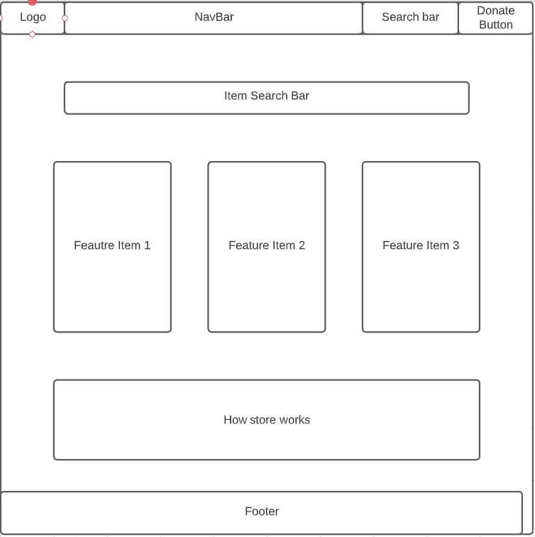

**Description**

This is the page the user sees when the click on the store button. They will first be shown a search bar at the top of the page which the user can use to search for specific items. Below the search bar are three feature items which will show random items in the store which the user can purchase. The feature items will be in cards. At the bottom of the store page will show instructions on how the store works.

**Title**

Store

**Headings**

H3 – Search for an Item

H3 – How to use the store

**Content**

* Cards of each item.
* Instructions on how to use store.

**Calls to Action**

* Take user selected feature item
* Show items with keywords user
* Show intsructions on how store works

**Plugins**

**-**Angular

-Express

**Functionality**

* Donate button takes user to donation page
* View item button takes user to selected item

### Listings

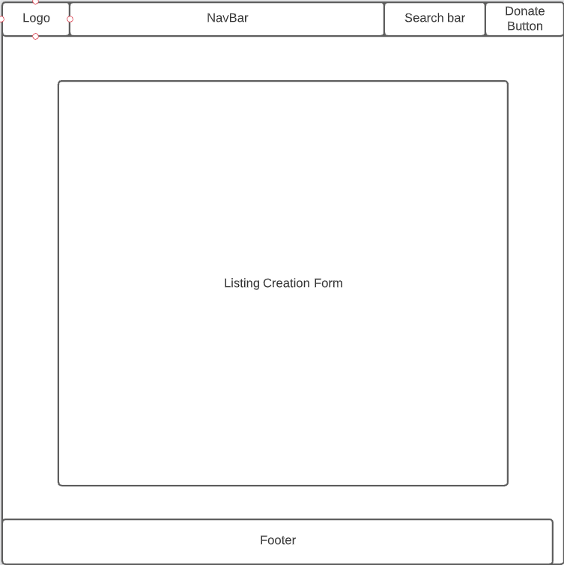

**Description**

This page is opened when a supplier wants to add a new listing to the store. They will be shown a form of which will have input fields the user will need to fill out. At the bottom of the page will be a ‘create listing’ button which will add the listing to the store.

**Title**

Add New Listing

**Headings**

H1 – Add New Listing

H3 – Listing details

**Content**

* Input fields

**Calls to Action**

* Add listing to store

**Plugins**

**-**Angular

-Express

**Functionality**

* Donate button takes user to donation page
* Add New Listing button will add listing to store

### News

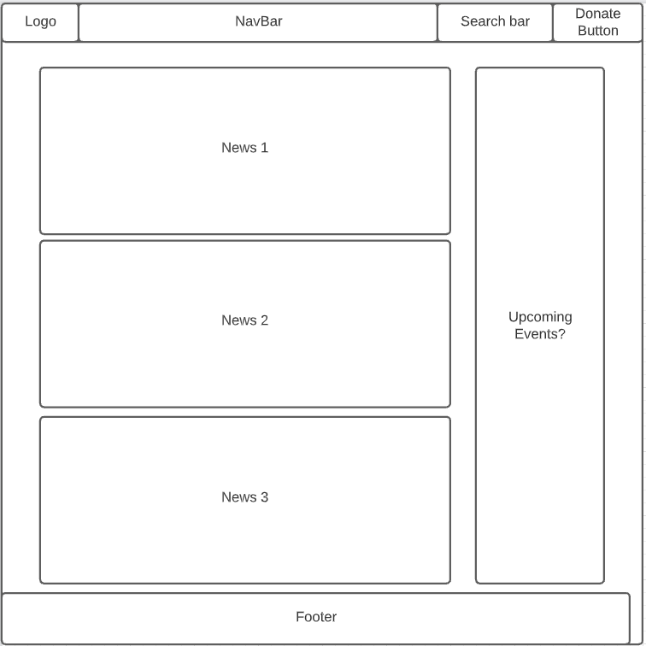

**Description**

The page is what the user will see when they click the news button on the navbar. The user will be presented with news about the charity. The news listings will be placed in chronological order from latest to oldest. To the right of the news listings will a list of all the events/dates related to the charity.

**Title**

News

**Headings**

H2 – News

H2 – Upcoming Events

**Content**

* News listings
* Upcoming Events/Dates

**Calls to Action**

* Extend card of news item to view full article.

**Plugins**

**-**Angular

-Express

**Functionality**

* Viewing a news article from the list will enlarge it showing the full article
* Donate button takes user to donation page

### Login

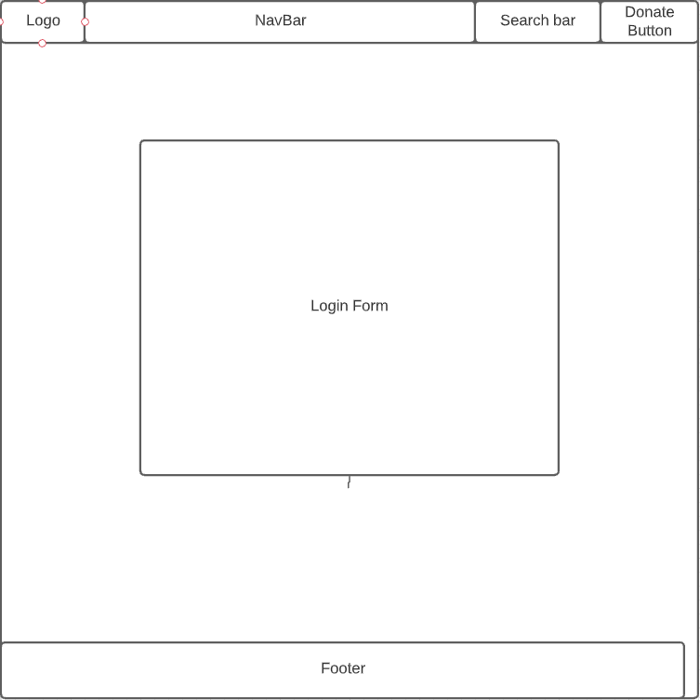

**Description**

This is what the user will see when the click the login button on the navbar. When loading into the page, the user will be presented with two options on who to login as. A ‘beneficiary’ or a ‘supplier/donator.’ When the option is selected They will be shown a form which will have input fields the user will have to fill out. Once the user is ready to login, they press the login button and will be taken to the home page.

**Title**

Login

**Headings**

H1 – Login

**Content**

* Login Form (Buttons, Input Fields)

**Calls to Action**

* Check if account exists when ‘login’ button pressed

**Plugins**

**-**Angular

-Express

**Functionality**

* User uses form to access account

### Register

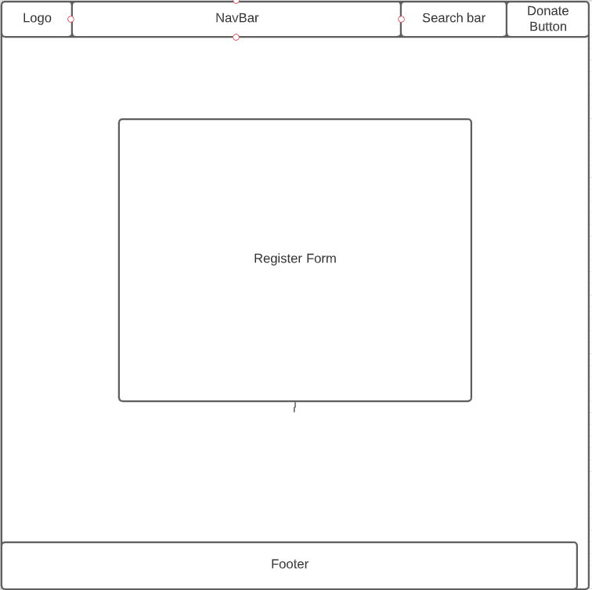

**Description**

This is what the user will see when the click the register button on the navbar. The user will first be shown two options which will ask if they want to register as a ‘beneficiary’ or a ‘Supplier/Donator’. When the option is selected, they will be shown a form of which the user will have to fill out. Once they are satisfied with the entered details, they can press the register button and it will create an account.

**Title**

Register

**Headings**

H1 - Register

**Content**

* Register Form (Buttons, Input Fields)

**Calls to Action**

* Check if account exists when ‘register’ button pressed.
* Add new account when account doesn’t exist

**Plugins**

**-**Angular

-Express

**Functionality**

* Create a new account.

### Donate

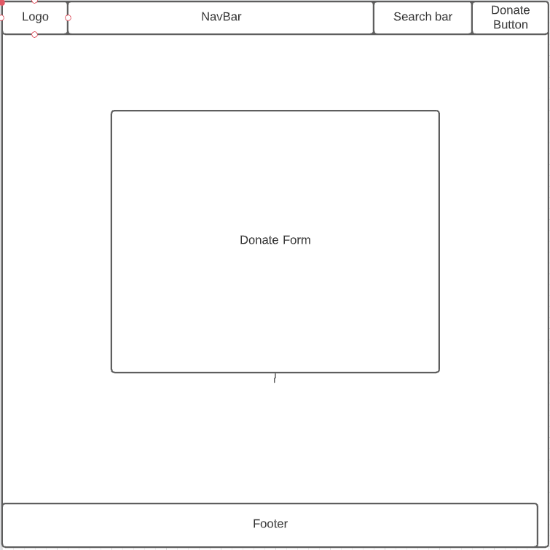

**Description**

This is what the user sees when they press the donate button in the top right of the navbar or a donate button in any page. They will be presented with a donation form of which can be filled out. There will be buttons containing set amounts or the user can enter a custom amount.

**Title**

Donate

**Headings**

**Content**

* Buttons
* Input Fields

**Calls to Action**

Send donation to charity.

**Plugins**

**-**Angular

-Express

**Functionality**

* Used to make a donation to the charity

# Crud Analysis.

|  |  |  |  |  |  |
| --- | --- | --- | --- | --- | --- |
| **No.** | **Action** | **Create** | **Read** | **Update** | **Delete** |
| 1. | Supplier creates an account | Supplier | Supplier |  |  |
| 2. | Supplier Logs In |  | Supplier |  |  |
| 3. | Beneficiary creates an account | Beneficiary | Beneficiary |  |  |
| 4. | Beneficiary Logs In |  | Beneficiary |  |  |
| 5. | Supplier adds new supplies | Supplier, Listing | Supplier, Listing |  |  |
| 6. | Supplier edits existing listing |  | Supplier, Listing | Supplier, Listing |  |
| 7. | Supplier deletes existing listing |  | Supplier, Listing |  | Supplier, Listing |
| 8. | Check the news |  | News |  |  |
| 9. | View the store |  | Listing |  |  |
| 10. | Open the home page |  | News |  |  |
| 11. | Donates to the charity |  | Donator |  |  |

# User Stories.

1. As a new supplier, I want to create an account so I can donate/supply school supplies so people that need it can purchase it.
2. As an existing supplier, I want to login to the website so I can add a listing of some supplies.
3. As a new beneficiary to the website, the beneficiary will want to create an account and know they will be creating an account as a beneficiary and not a supplier as I’m struggling to meet the course costs and require supplies for the current school costs.
4. As an existing beneficiary, I want to login to the website so I can use my current tokens to purchase supplies.
5. As a supplier, I want to add a listing of school supplies up for purchase so a beneficiary can purchase my supplies with their tokens.
6. As a supplier, I want to edit an existing listing that I have already made so I can update the listing with the correct description and title
7. As a supplier, I want to be able to delete an existing listing as the item is no longer available.
8. As a member of the public, I want to know the current news associated with this charity.
9. As a beneficiary, I want to be able to view what supplies are available for purchase using my tokens.
10. As a member of the public, I want to know what the website is about when I open the website but also want to be engaged with the content.
11. As a donator, I want to be able to donate money from any page on the website so I can contribute to getting school supplies to those in need.

# Summary and Conclusion

This report will be used to develop the website for the Supplies for School charity.